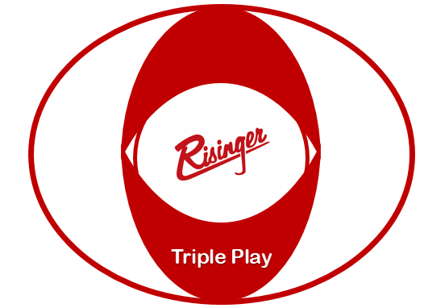

Triple Play Pay Program
Effective November 22nd, 2021

$1,000 Guaranteed Maintenance Pay Guidelines
Risinger recognizes that maintenance breakdowns can have a negative impact on earning capabilities. To ease that negative impact, Risinger has created a program that will guarantee to all Lease Purchase Contractors in a 2015 or newer truck, that run into maintenance issues, a minimum settlement of $1,000/week.

This program is intended to illustrate the importance of being available to work on Monday each week while experiencing maintenance breakdown issues in order to be successful here at Risinger.
This is an optional program which will require you to enroll by sending Qualcomm message #46 stating you understand the guidelines listed below:
- Available and ready to run by 8:00 am (CT) on Monday (or no later than the end of your 34 hour reset) and remain available/running through Saturday at noon.
  - You are considered available if your truck is in the shop for maintenance as long as you begin running as soon as the repairs have been completed.
    - If maintenance is completed and contractor is notified before noon, contractor must return to the truck the same day to receive minimum pay support.
    - If maintenance is completed and contractor is notified after noon, contractor must return to the truck no later than the following morning by 10 AM to receive minimum pay support.
    - PM’s should be completed during scheduled home time when possible. If the contractor refuses to have the PM performed while on home time, he/she will not be eligible for minimum pay support for the week.
  - Support will not be paid if a loaner truck is offered and turned down by the contractor. Support will also not be paid if other work (such as truck recovery) is declined by the contractor.

Support amount is calculated on the contractor’s net settlement before deducting for cash advances, accident deductibles, child support, and wage garnishments.
- Example #1 – Settlement check amount is $850 and a $200 advance was taken. Contractor would not be eligible for additional support, since the gross settlement would have been $1,050 had the advance not been taken.
- Example #2 – Settlement check amount is $925, which includes a $100 deduction for child support. The contractor would not be eligible for additional support since his/her gross settlement would have been $1,025 without the child support deduction.

$12,000 Sign-on Bonus Program
- The $12,000 will be paid as follows:
  - If you arrive to Orientation on a Monday - You will receive the payment of $500 the Friday immediately after orientation (along with your $200 orientation pay).
  - If you arrive to Orientation on a Wednesday - You will receive $500 the Friday following the completion of orientation (along with your $200 orientation pay).
  - The other $500 will be received on the following week on Friday (based on completion of first load.)
  - $500 – Next two settlements.
  - $5,000 bonus will be paid out in one lump sum after your 6 month anniversary with Risinger provided you have also run the minimum required 52,000 miles.
  - An additional $5,000 bonus will be paid out in one lump sum after your 1 year anniversary.
  - Payments will be made via direct deposit or Comdata card load depending on your preference.
  - The contractor must successfully complete orientation, complete the delivery of their first load, and be actively running to receive the bonus on the payout dates.
  - Up to 50% of any sign-on bonus will be applied toward any debt owed to Risinger.
  - Rehires
    - If contractor has been gone for over 1 year, he/she is eligible for the above terms.
    - If contractor has been gone for less than 1 year, but more than 3 months he/she will receive the orientation pay.

$1,000 Quarterly High Roller Bonus Program
Earn up to $5,000 in bonuses simply by driving safely and meeting mileage requirements! Each quarter a driver is rewarded based on the tired scheduled below with bonuses ranging from $250 to $1,000 per quarter. When a contractor completes 4 quarters of over 33,000 miles, he or she will receive an additional $1,000. The 4 quarters of over 33,000 do not have to be consecutive.

For Team Drivers:
For Single Drivers: (Payouts are per driver)
Low Miles | High Miles | Payout
52,000 | 56,000 | $250
56,001 | 60,000 | $500
60,001 | 66,000 | $750
66,001 | and up | $1,000

Low Miles | High Miles | Payout
26,000 | 28,000 | $250
28,001 | 30,000 | $500
30,001 | 33,000 | $750
33,001 | and up | $1,000

High Roller Bonus Eligibility
- The Contractor must complete any required training materials.
- The Contractor must be qualified and actively driving for Risinger on the day the bonus is paid. If a contractor is disqualified or terminated prior to the payout of the bonus, he or she does not accrue any bonus for the period.
- A Contractor is NOT eligible if he or she receives any unsafe points or a combination of 30 or more points in any other category during the quarter.
- A Contractor is NOT eligible if he or she has a preventable accident that results in an expense to Risinger of $5,000 or more.
- Up to half (50%) of the total bonus payout can and will be applied to any existing debt owed to Risinger.

After reading and understanding the details of the Triple Play Program I, _____________________________, elect to participate in this program. I understand that this is not a contractual obligation and may be modified or discontinued at Risinger’s discretion. I acknowledge receipt of a copy of the Triple Play Program details.

Signature: ___________________________ Date: __________
Print Name: ___________________________ Date: _________

